**MODULE-3**

**INTRODUCTION TO GRAPH THEORY**

*Introduction- Basic definition – Application of graphs-finite, infinite and bipartite graphs –*

*Incidence and Degree – Isolated vertex, pendant vertex and Null graph. Paths and circuits – Isomorphism, sub graphs, walks, paths and circuits, connected graphs, disconnected graphs and components, Eulerian and Hamiltonian graphs, Travelling salesman problem.*

**Introduction to Graph Theory**

A linear graph (or simply a graph) 𝐺 = (𝑉, 𝐸) consists of a set of objects 𝑉 = {𝑣1 , 𝑣2 , … } called *vertices*, and another set 𝐸 = {𝑒1 , 𝑒2, … }, whose elements are called *edges*, such that each edge 𝑒𝑘 is identified with an unordered pair (𝑣𝑖 , 𝑣𝑗 ) of vertices. The vertices 𝑣𝑖 ,

𝑣𝑗 associated with edge 𝑒𝑘 are called the *end vertices* of 𝑒𝑘 .

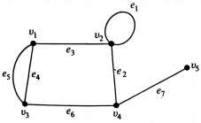

Fig. A graph with five vertices and seven edges.

**Application of graphs**

# Konigsberg Bridge Problem

The Konigsberg bridge problem is perhaps the best known example in graph theory. It was a long standing problem until solved by Leonhard Euler (1707 – 1783) in 1736, by means of a graph. Euler wrote the first paper ever in graph theory and thus became the originator of the theory of graphs as well as of the rest of topology. The problem is depicted in Fig. a).

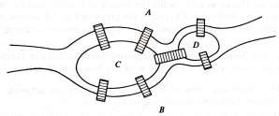

Fig.a) Konigsberg bridge problem

Two islands, *C* and *D,* formed by the Pregel River in Königsberg (then the capital of East Prussia but now renamed Kaliningrad and in West Soviet Russia) were connected to each other and to the banks *A* and *B* with seven bridges, as shown in Fig.a). The problem was to start at any of the four land areas of the city, *A*, *B*, *C*, or *D,* walk over each of the seven bridges *exactly once*, and return to the starting point (without swimming across the river, of course). Euler represented this situation by means of a graph, as shown in Fig. b). The vertices represent the land areas and the edges represent the bridges. Euler proved that a solution for this problem does not exist.

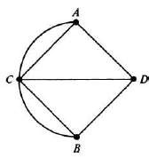

Fig.b) Graph of Königsberg bridge problem

# Utilities Problems

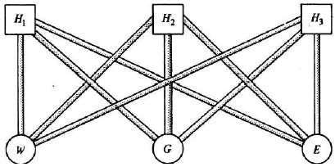

Fig. c) Three-utilities problem

There are three houses (Fig. c) 𝐻1 , 𝐻2 and 𝐻3, each to be connected to each of the three utilities – water (W), gas (G), and electricity (E) –by means of conduits. Is it possible to make such connections without any crossovers of the conduits?

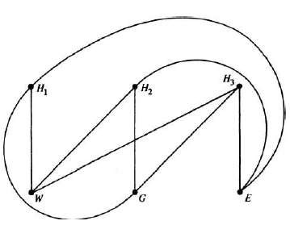

Fig. d) Graph of three-utilities problem

Fig. d) shows how this problem can be represented by a graph-the conduits are shown as edges while the houses and utility supply centers are vertices. The graph in Fig.d) cannot be drawn in the plane without edges crossing over. Thus, the answer to the problem is no.

# Seating Problems

Nine members of a new club meet each day for lunch at a round table. They decide to sit such that every member has different neighbors at each lunch. How many days can this arrangement last? This situation can be represented by a graph with nine vertices such that each vertex represents a member, and an edge joining two vertices represents the relationship of sitting next to each other. Fig.e) shows two possible seating arrangements—these are 1 2 3 4 5 6 7 8 9 1 (solid lines), and 1 3 5 2 7 4 9 6 8 1 (dashed lines). It can be shown by graph-theoretic considerations that there are only two more arrangements possible. They are 1 5 7 3 9 2 8 4 61 and 1 7 9 5 8 3 6 2 4 1. In general, it can be shown that for *n* people the number of such possible arrangements is 𝑛−1 if n is odd and 𝑛−2 if n is even.

2 2

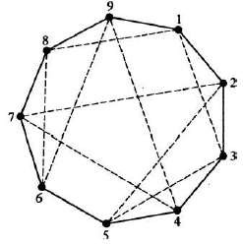

Fig.e) Arrangements at a dinner table.

# Graphs

A *Graph* is a pair (V,E) where V is a nonempty set and E is a set of unordered pairs of elements taken from the set V.

For a graph (V,E), the elements of V are called *vertices* (or points or nodes) and the elements of E are called *edges.* The set V is called the *vertex set* and the set E is called the *edge set*.

A *directed graph* (or a *digraph*) is a pair (V, E), where V is a nonempty set and E is a set of ordered pairs of elements taken from set V.

***Null graph***

A graph containing no edges is called a *null graph*.

***Trivial graph***

A null graph with only one vertex is called a *trivial graph*.

# Order and size

The number of vertices in a graph is called the *order* of the graph, denoted by *n* or |V| and the number of edges in it is called its *size*, denoted by *m* or |E|*.*

The vertices of a graph is denoted by A,B,C, etc or 𝑣1, 𝑣2, 𝑣3, etc. and we denote the edges of a graph by 𝑒1, 𝑒2, 𝑒3, and so on.

# End vertices

If 𝑣𝑖 and 𝑣𝑗 denote two vertices of a graph and if 𝑒𝑘 denotes an edge joining 𝑣𝑖 and 𝑣𝑗, then 𝑣𝑖 and 𝑣𝑗are called the *end vertices* (or end points) of 𝑒𝑘.

# Loop

If in a graph, an edge 𝑒𝑘 has the same vertex 𝑣𝑖 as both of its end vertices, such edge 𝑒𝑘 is called a *loop*.

# Parallel edges

If in a graph, two edges 𝑒𝑘 and 𝑒𝑙 have same end vertices 𝑣𝑖 and 𝑣𝑗, such edges are called *parallel edges*.

# Multiple edges

If in a graph, there are two or more edges with the same end vertices, the edges are called *multiple edges.*

# Simple graph

A graph which does not contain loops and multiple edges is called a *simple graph*.

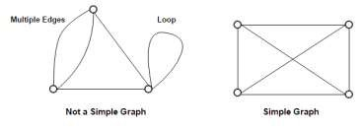

***Loop-free graph***

A graph which does not contain a loop is called a *loop-free graph*.

***Multigraph***

A graph which contains multiple edges but no loops is called a *multigraph*.

***General graph***

A graph which contains multiple edges or loops (or both) is called a *general graph*.

# Complete graph

A simple graph of order ≥ 2 in which there is an edge between every pair of vertices is called a complete graph and is denoted by 𝐾𝑛.

A complete graph 𝐾𝑛 with *n* vertices, has ⬚𝑛𝐶2 = 12 𝑛 (n − 1) edges.

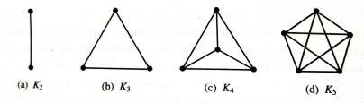

# Finite and infinite graph

A graph with a finite number of vertices as well as a finite number of edges is called a *finite* *graph*. Otherwise, it is an *infinite graph*.

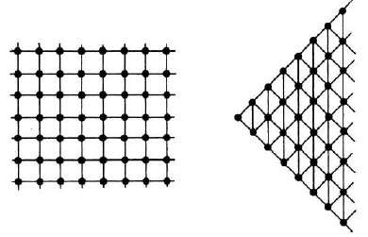

Fig: Portions of two infinite graphs

# Bipartite graphs

Suppose a *simple graph* G is that its vertex set V is the union of two of its mutually *disjoint* nonempty subsets 𝑉1 and 𝑉2 which are such that each edge in G joins a vertex in 𝑉1 and a vertex in 𝑉2. Then G is called a ***bipartite graph***.

If E is the edge set of this graph, the graph is deno;ted by G= (𝑉1, 𝑉2; 𝐸), or G = G(𝑉1, 𝑉2; 𝐸). The sets 𝑉1 and 𝑉2 are called ***bipartites*** (or *partitions*) of the vertex set V.

For example,

Consider the graph G shown in Figure 1.20 for which the vertex set V = {A,B,C,P,Q,R,S} and the edge set is E={AP, AQ, AR, BR, CQ, CS}. Note that the set V is the union of two of its subsets 𝑉1 = {A,B,C} and 𝑉2 = {P,Q,R,S} which are such that (i) 𝑉1 and 𝑉2 are disjoint, (ii) every edge in G joins a vertex in 𝑉1 and a vertex in 𝑉2, (iii) G contains no edge that joins two vertices both of which are in 𝑉1 or 𝑉2.

This graph is a bipartite graph with 𝑉1 ={A,B,C} and 𝑉2 = {P,Q,R,S} as bipartices.

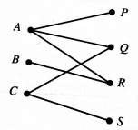

Figure 1.20

# Complete Bipartite graph

A Bipartite graph G= (𝑉1, 𝑉2; 𝐸) is called a ***complete bipartite graph*** if there is an edge between every vertex in 𝑉1 and every vertex in 𝑉2.

A complete bipartite graph G= (𝑉1, 𝑉2; 𝐸) in which the bipartites 𝑉1 and 𝑉2 contain *r* and *s* vertices respectively, with *r* ≤ *s,* is denoted by 𝐾𝑟,𝑠. In this graph, each of *r* vertices in 𝑉1is joined to each of *s* vertices in 𝑉2. Thus, 𝐾𝑟,𝑠 has *r + s* vertices and *r s* edges; that is 𝐾𝑟,𝑠 is of order *r + s* and of size *rs;* it istherefore a (*r + s, r s)* graph*.*

Figures 1.21(a) to 1.21(d) depict some complete bipartite graphs. Observe that in figure 1.21(a), the bipartites are 𝑉1  *=* {A}and 𝑉2 = {P,Q,R}; the vertex A is joined to each of the vertices P,Q,R by an edge. In figure 1.21(b), the bipartites are 𝑉1  *=* {A} and 𝑉2={M,N,P,Q,R}; the vertex A is joined to each of the vertices M,N,P,Q,R, by an edge.

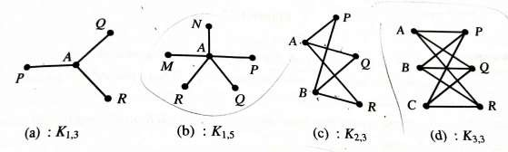

Figures 1.21

In figure 1.21(c), the bipartites are 𝑉1 {A,B} and 𝑉2 = {P,Q,R}; each of the vertices A and B is joined to each of the vertices P, Q, R by an edge. In Figure 1.21(d), the bipartices are 𝑉1

{A,B,C} and 𝑉2 = {P,Q,R}; each of the vertices A,B,C is joined to each of the vertices P,Q,R.

**Problem 1:** Draw a diagram of the graph G=(V,E) in each of the following cases:

1. V= {A,B,C,D}, E = {AB, AC, AD, CD}
2. V = {𝑣1 𝑣2 𝑣3 𝑣4 𝑣5}, E = {𝑣1𝑣2 , 𝑣1𝑣3, 𝑣2𝑣3, 𝑣4𝑣5} (iii) V= {P,Q,R,S,T}, E = {PS, QR, QS,}

(iv) V = {𝑣1, 𝑣2, 𝑣3, 𝑣4, 𝑣5, 𝑣6}, E = {𝑣1𝑣4 , 𝑣1𝑣6, 𝑣4𝑣6, 𝑣3𝑣2,𝑣3𝑣5,𝑣2𝑣5,}

**Sol:** The required diagrams are shown below:

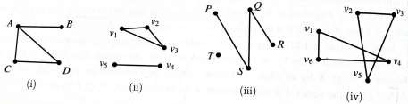

**Problem 2:** Which of the following graphs is a simple graph? a multigraph? a general graph?

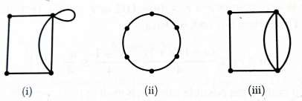

**Sol:** (i) General graph

1. Simple graph
2. Multigraph

**Problem 3:** Which of the following is a bipartite graph?

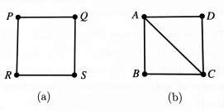

**Sol:** (a) Bipartite graph with 𝑉1 = {𝑃, 𝑆} and 𝑉2 = {𝑄, 𝑅}. (b) Not a bipartite graph.

**Problem 4:** (a) How many vertices and how many edges are there in the complete bipartite graphs K4,7 and K7,11?

(b) If the graph Kr,12 has 72 edges, what is r ?

**Sol:** The complete bipartite graph 𝐾𝑟,𝑠 has *r + s* vertices and *r s* edges.

(a)The graph 𝐾4,7 has 4+7 =11 vertices and 4 × 7 =28 edges, and the graph 𝐾7,11 has 18 vertices and 77 edges.

(b) If the graph 𝐾𝑟,12 has 72 edges, we have 12 *r* = 72 so that *r =6.*

**Problem 5:** Verify that the following are bipartite graphs. What are their bipartites?

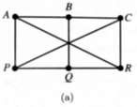

**Sol:** (a) For the given graph, the vertex set 𝑉 = {𝐴, 𝐵, 𝐶, 𝑃, 𝑄, 𝑅} and the edge set is E={AB, AP, AR, CB, CP, CR, QB, QP, QR}. The set V is the union of two of its subsets 𝑉1 = {A,C,Q} and 𝑉2 = {B,P,R} which are such that (i) 𝑉1 and 𝑉2 are disjoint, (ii) every edge in G joins a vertex in 𝑉1 and a vertex in 𝑉2, (iii) G contains no edge that joins two vertices both of which are in 𝑉1 or 𝑉2.

This graph is a bipartite graph with 𝑉1 = {A,C,Q} and 𝑉2 = {B,P,R} as bipartites.

**Problem 6:** State whether the following graphs can exist or cannot exist.

1. Simple graph of order 3 and size 2.
2. Simple graph of order 5 and size 12.
3. Complete graph of order 5 and size 10.

**Sol:** 1) Given n=3 and m=2.

For n=3, for connected graph 𝑚 =  𝑛(𝑛 − 1) = 3, but given 𝑚 = 2<3. Hence, graph of order

3 and size 2 can exist.

1. Given n=5 and m=12.

For n=5, for connected graph 𝑚 =  𝑛(𝑛 − 1) = 10, but given 𝑚 = 12>10. Hence, graph of order 5 and size 12 cannot exist.

1. Given n=5 and m=10.

For n=5, for connected complete graph 𝑚 =  𝑛(𝑛 − 1) = 10, but given 𝑚 = 10. Hence, a complete graph of order 5 and size 10 can exist.

**Homework:**

1. Which of the following are complete graphs ?

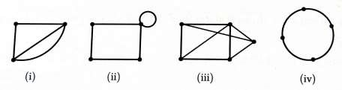

1. Verify that the following are bipartite graphs. What are their bipartites?

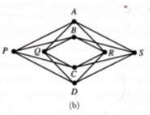

1. Which of the graphs shown below are bipartite graphs ?

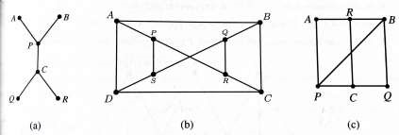

1. State whether the following graphs can exist or cannot exist.
   1. Bipartite graph of order 4 and size 3.
   2. Bipartite graph of order 4 and size 3.
   3. Complete bipartite graph of order 4 and size 4.

# Incidence and degree

When a vertex 𝑣𝑖  is an end vertex of some edge 𝑒𝑗 , then 𝑣𝑖 and 𝑒𝑗 are said to be *incident* with

(on or to) each other. In Fig. 1.1, for example, edges 𝑒2, 𝑒6 , and 𝑒7 are incident with vertex 𝑣4. Two non parallel edges are said to be *adjacent* if they are incident on a common vertex. For example 𝑒2 and 𝑒7 in Fig. 1.1 are adjacent.

The number of edges incident on a vertex 𝑣𝑖 , with self-loops counted twice, is called the *degree*, 𝑑(𝑣𝑖 ) or 𝑑𝑒𝑔(𝑣𝑖) of vertex 𝑣𝑖 .

In Fig. 1-1, for example, 𝑑(𝑣1 ) = 𝑑(𝑣3 ) = 𝑑(𝑣4 ) = 3 , 𝑑(𝑣2 ) = 4, and 𝑑(𝑣5 ) = 1.

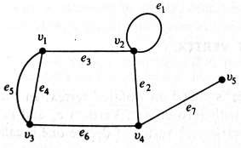

**Fig. 1-1** A graph with five vertices and seven edges.

# Isolated vertex

A vertex in a graph which is not an end vertex of any edge of the graph is called an *isolated vertex*. Isolated vertex has degree zero.

***Pendant vertex***

A vertex of degree 1 is called a *pendant vertex*.

# Pendant edge

An edge incident on a pendant vertex is called a *pendant edge*.

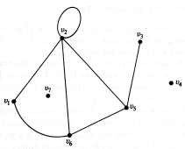

Fig. Graph containing isolated vertices, and a pendant vertex.

# Regular graph

A graph in which all the vertices are of the same degree *k* is called a *regular graph* *of degree k,* or a *k-regular graph.*

In particular, a 3 – regular graph is called a *cubic graph.*

The graphs shown in Figures a) and b) are 2-regular and 4-regular graphs respectively.

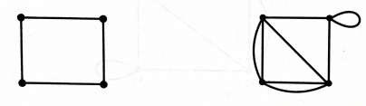

a) b)

# Handshaking property

Let us now consider a graph G with e edges and n vertices 𝑣𝑖 , 𝑣2 , ….𝑣𝑛 . Since each edge contributes two degrees, the sum of the degrees of all vertices in G is twice the number of edges in G. That is, .

Taking Fig. 1-1 as an example,



**Fig. 1-1** A graph with five vertices and seven edges.



= twice the number of edges.

**Theorem:** *The number of vertices of odd degree in a graph is always even.*

**Proof:** If we consider the vertices with odd and even degrees separately, the quantity in the left side of Eq. (1-1)

𝑒 Eq. (1-1)

can be expressed as the sum of two sums, each taken over vertices of even and odd degrees, respectively, as follows:

⬚𝑒𝑣𝑒𝑛 𝑑( 𝑣𝑗 ) + ∑⬚𝑜𝑑𝑑 𝑑( 𝑣𝑘 ) Eq. (1-2) Since the left-hand side in Eq. (1-2) is even, and the first expression on the right-hand side is even (being a sum of even numbers), the second expression must

∑⬚𝑜𝑑𝑑 𝑑( 𝑣𝑘 ) = an even number Eq. (1-3) Because in Eq. (1-3) each 𝑑(𝑣𝑘) is odd, the total number of terms in the sum must be even to make the sum an even number. Hence the theorem.

**Problem 1:** For the graph shown in Figure, indicate the degree of each vertex and verify the handshaking property:

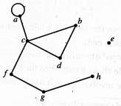

**Sol:** The degree of its vertices are as given below: deg*(a)* = 3, deg*(b)* = 2, deg*(c)* = 4, deg*(d)* = 2, deg*(e)* = 0, deg*( f )* = 2, deg*(g)* = 2, deg*(h)* = 1.

We note that *e* is an isolated vertex and *h* is a pendant vertex.

Further, the sum of the degrees of vertices is equal to 16. Also, the graph has 8 edges.

Thus, the sum of the degrees of vertices is equal to twice the number of edges. This verifies the handshaking property for the given graph.

**Problem 2:** Can there be a graph consisting of the vertices A, B,C,D with deg(A) = 2, deg(B) =3, deg(C)=2, deg(D)=2?

**Sol:** In every graph, the sum of the degrees of the vertices has to be an even number. Here, this sum is 9 which is not even. Therefore, there does not exist a graph of the given kind.

**Problem 3:** Can there be a graph with 12 vertices such that two of the vertices have degree 3 each and the remaining 10 vertices have degree 4 each?

**Sol:** Here, the sum of the degrees of vertices is (3×2) + (4×10) = 46. Therefore, if *m*=23, we have 2*m*=46 and the handshaking property holds. Hence there can be a graph of the desired type (whose size is 23).

**Problem 4:** Determine |𝑉| for the following graphs or multigraphs 𝐺.

1. 𝐺 has nine edges and all vertices have degree 3.
2. 𝐺 is regular with 15 edges.
3. 𝐺 has 10 edges with two vertices of degree 4 and all others of degree 3.

**Sol:** We know that for a G = (V, E) an undirected graph or multigraph, ∑𝑣∈𝑉 deg(𝑢) = 2|𝐸|.

1. Consider, ∑𝑣∈𝑉 deg(𝑢) = 2|𝐸|
   1. |𝑉| = 2(9) ∴ |𝑉| = 6.
2. Consider, ∑𝑣∈𝑉 deg(𝑢) = 2|𝐸|

𝑘 |𝑉| = 2(15) = 30

For 𝑘 = 1, 2, 3, 5, 6, 10, 15, 30, we get |𝑉| = 30, 15, 10, 6, 5, 3, 2, 1.

1. Consider, ∑𝑣∈𝑉 deg(𝑢) = 2|𝐸|

2(4) + 3𝑥 = 2(10) where |𝑉| = 4 + 𝑥

* 1. 𝑥 = 20 − 8 = 12

𝑥 = 4

∴ |𝑉| = 4 + 𝑥 = 4 + 2 = 6.

**Homework**

1. Draw all simple graphs of one, two, three, and four vertices.
2. Draw graphs representing problems of (a) two houses and three utilities; (b) four houses and four utilities, say, water, gas, electricity, and telephone.
3. Draw graphs of the following chemical compounds: (a) CH4 , (b) C2H6, (c) C6H6, (d) N2O3. (Hint: Represent atoms by vertices and chemical bonds between them by edges.)
4. Find the degrees of all the vertices of the graph shown in Figure a). Also, verify the handshaking property for this graph.

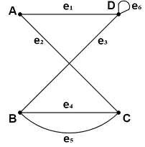 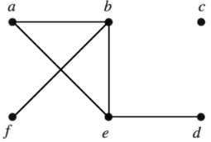

Fig a) Fig b)

1. Verify the handshaking property for the graph shown in Figure b).
2. Are the following graphs regular?

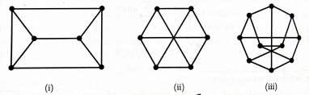

1. How many vertices will the following graphs have, if they contain
   1. 16 edges and all vertices of degree 4?
   2. 21 edges, 3 vertices of degree 4, and other vertices of degree 3?
   3. 12 edges, 6 vertices of degree 3, and other vertices of degree less than 3.

# Isomorphism

Two graphs G and G’ are said to be *isomorphic* (to each other) if there is a one-to-one correspondence between their vertices and between their edges such that the incidence relationship is preserved.

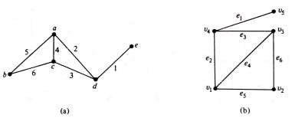

Fig. 2-1 Isomorphic graphs.

For example, the two graphs in Fig. 2-1 are isomorphic. The correspondence between the graphs is as follows : The vertices a, b, c, d, and e correspond to 𝑣1 , 𝑣2 𝑣3 , 𝑣4 , and 𝑣5 , respectively. The edges 1,2,3,4,5 and 6 correspond to 𝑒1 , 𝑒2 ,𝑒3 , 𝑒4 , 𝑒5 , and 𝑒6 , respectively.

It is immediately apparent by the definition of isomorphism that two isomorphic graphs must have.

1. The same number of vertices.
2. The same number of edges.
3. An equal number of vertices with a given degree.

**Problems:**

1. Prove that the two graphs shown below are isomorphic.

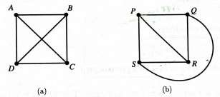

**Sol:** Consider the following one-to-one correspondence between the vertices of these two graphs: A ↔ P, B ↔ Q, C ↔ R, D ↔ S.

Under this correspondence, the edges in the two graphs correspond with each other, as indicated below:

{A, B} ↔ {P, Q}, {A, C} ↔ {P, R}, {A, D} ↔ {P, S},

{B, C} ↔ {Q, R}, {B, D} ↔ {Q, S}, {C, D} ↔ {R, S}

These represent one-to-one correspondence between the edges of the two graphs under which the adjacent vertices in the first graph correspond to adjacent vertices in the second graph and vice-versa.

Accordingly, the two graphs are isomorphic.

1. Prove that the two graphs shown below are isomorphic.

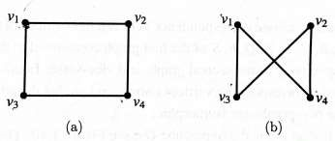

**Sol:** We first observe that the both graphs have four vertices and four edges. Consider the following one-to-one correspondence between the vertices of the graphs:

𝑢1 ↔ 𝑣1, 𝑢2 ↔ 𝑣4, 𝑢3 ↔ 𝑣3, 𝑢4 ↔ 𝑣2.

This correspondence gives the following correspondence between the edges:

{𝑢1, 𝑢2} ↔ {𝑣1, 𝑣4}, {𝑢1, 𝑢3} ↔ {𝑣1, 𝑣3},

{𝑢2, 𝑢4} ↔ {𝑣4, 𝑣2}, {𝑢3, 𝑢4} ↔ {𝑣3, 𝑣2},

These represent one-to-one correspondence between the edges of the two graphs under which the adjacent vertices in the first graph correspond to adjacent vertices in the second graph and vice-versa. Accordingly, the two graphs are isomorphic.

1. Verify that the two graphs shown below are isomorphic.

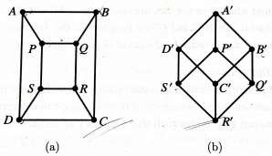

**Sol:** Let us consider the one-to-one correspondence between the vertices of the two graphs under which the vertices A, B, C, D, P, Q, R, S of the first graph correspond to the vertices 𝐴′ ,

𝐵′ , 𝐶′ , 𝐷′ , 𝑃′ , 𝑄′ , 𝑅′ , 𝑆′  respectively of the second graph and vice-versa. In this correspondence, the edges determined by the corresponding vertices correspond so that the adjacency of vertices is retained. As such, the two graphs are isomorphic.

1. Show that the following two graphs are isomorphic.

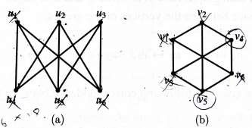

**Sol:** The graphs have six vertices each of degree three, and nine edges. Consider the correspondence between the edges as shown below.

{𝑢1, 𝑢4} ↔ {𝑣1, 𝑣2}, {𝑢1, 𝑢5} ↔ {𝑣1, 𝑣3}, {𝑢1, 𝑢6} ↔ {𝑣1, 𝑣6}

{𝑢2, 𝑢5} ↔ {𝑣4, 𝑣3}, {𝑢2, 𝑢4} ↔ {𝑣4, 𝑣2}, {𝑢2, 𝑢6} ↔ {𝑣4, 𝑣6},

{𝑢3, 𝑢6} ↔ {𝑣5, 𝑣6}, {𝑢3, 𝑢4} ↔ {𝑣5, 𝑣2}, {𝑢3, 𝑢5} ↔ {𝑣5, 𝑣3},

These yield the following correspondence between the vertices:

𝑢1 ↔ 𝑣1, 𝑢2 ↔ 𝑣4, 𝑢3 ↔ 𝑣5,

𝑢4 ↔ 𝑣2, 𝑢5 ↔ 𝑣3, 𝑢6 ↔ 𝑣6.

We observe that the above correspondences between the edges and the vertices are one-to-one correspondences and that these preserve the adjacency of vertices. In view of the existence of these correspondences, we infer that the two graphs are isomorphic.

1. Show that the following graphs are not isomorphic.

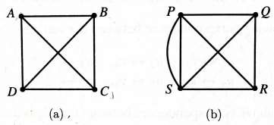

**Sol:** The first graph has 4 vertices and 6 edges and the second graph has 4 vertices and 7 edges. As such, one-to-one correspondence between the edges is not possible. Hence the two graphs are *not* isomorphic.

1. Which if any, of the pairs of graphs shown in Fig are isomorphic. Justify.

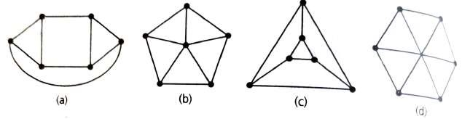

**Sol:**

1. Graphs (a) (c) (d) are regular (*ie*, each vertex has the same degree). But (b) is not regular since one vertex has degree 5, while the remaining vertices have degree 3.
2. Graphs (a) and (c) have each two cycles of length 3 whereas (d) has no cycle of length 3.

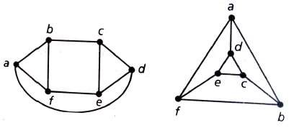

1. So compare graphs (a) and (c) only. (a) and (c) have the same number of six vertices and the same number of nine edges. The two cycles in each graph are {*a,b,f*} and {*c,d,e*}. Also {*b,c,e,f*} is a cycle of length 4. Thus the two graphs (a) and (c) are isomorphic.

**7.** Draw all non-isomorphic, cycle-free, connected graphs having six vertices. **Sol:**

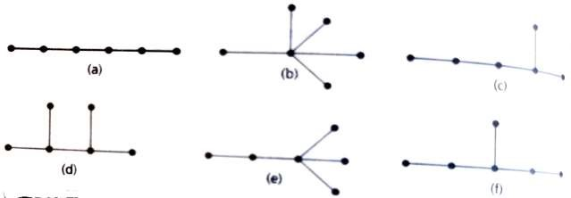

The graph in Fig. (a) (b) (c) (d) (e) (f) are cycle free, connected graphs each having six vertices. Further they are all non-isomorphic. For example (a) and (b) are non-isomorphic since there is a vertex in (b) having degree 5 which (a) does not have.

Again (c) has a vertex of degree 3, which (a) does not have. Since (c) has a vertex of degree 3 which (b) has a vertex of degree 5, (c) and (b) are not isomorphic and so on.

**Homework:**

1. Show that the following graphs are isomorphic.

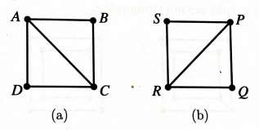

1. Show that the following graphs are isomorphic.

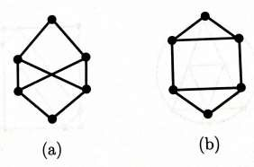

1. Show that the following graphs are isomorphic.

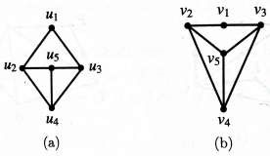

1. Show that the following graphs are not isomorphic.

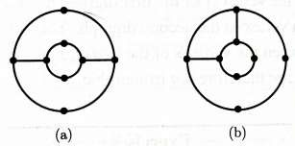

1. Show that the following graphs are not isomorphic.

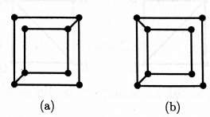

1. Verify that the following graphs are isomorphic.

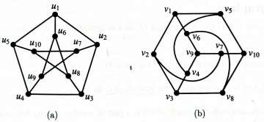

# Subgraphs

A graph *g* is said to be a *subgraph* of a graph *G* if all the vertices and all the edges of *g* are in *G*, and each edge of *g* has the same end vertices in *g* as in *G*.

For instance, the graph in Fig. 2-5(b) is a subgraph of the one in Fig.2-5(a) .

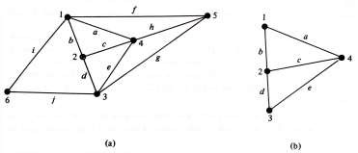

Fig. 2-5 Graph (a) and one of its sub graphs (b)

The symbol from set theory, g ⊂ G, is used in stating “ g is a subgraph of G.”

# Spanning Subgraph

Given a graph *G* = (V,E), if there is a subgraph 𝐺1 = (𝑉1, 𝐸1) of *G* such that 𝑉1 = V, then 𝐺1 is called a *spanning subgraph* of *G*.

In other words, a subgraph 𝐺1 of a graph *G* is a spanning subgraph of *G* whenever 𝐺1 contains all vertices of *G.*

For example, for the graph shown in Figure 1.69 (a), the graph shown in Figure 1.69(b) is a spanning subgraph whereas the graph shown in Figure 1.69(c) is a subgraph but not a spanning subgraph.

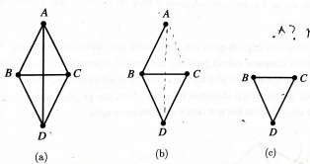

Figure 1.69

# Induced Subgraph

Given a graph *G* = (V,E), suppose there is a subgraph 𝐺1 = (𝑉1, 𝐸1) of *G* such that every edge {A,B} of *G*, where A, B ∈ 𝑉1  is an edge of 𝐺1 also. Then 𝐺1 is called an *induced subgraph* of

*G* (induced by 𝑉1 ) and is denoted by < 𝑉1 >.

For example, for the graph shown in the Figure 1.70(a), the graph shown in Figure 1.70(b) is an induced subgraph – induced by the set of vertices 𝑉1 = {𝑣1, 𝑣2, 𝑣3, 𝑣5,}, whereas the graph shown in Figure 1.70(c) is not an induced subgraph.

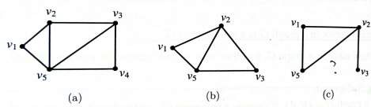

Figure 1.70

**Problem 1:** Consider the graph G shown in Figure 1.73(a).

1. Verify that the graph G1 shown in Figure 1.73(b) is an induced subgraph of G. Is this spanning subgraph of G?
2. Draw the subgraph G2of G induced by the set V2 = {v3, v4, v6, v8, v9 }.

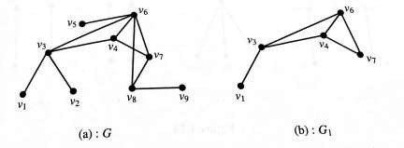

Figure 1.73

**Sol:** (a) The vertex set of the graph 𝐺1, namely 𝑉1 = {𝑣1, 𝑣3, 𝑣4, 𝑣6, 𝑣7 }, is a subset of the vertex set V ={ 𝑣1, 𝑣2, ……. 𝑣9 } of *G.*

Also, all the edges of 𝐺1 are in G, Further, each edge in 𝐺1 has the same end vertices in *G* as in 𝐺1. Therefore, 𝐺1 is a subgraph of *G.*

Further every edge { 𝑣𝑖, 𝑣𝑗,} of *G* where 𝑣𝑖, 𝑣𝑗, ∈ 𝑉1 is an edge of 𝐺1. Therefore, 𝐺1 is an induced subgraph of *G.* Since𝑉1≠V*,* 𝐺1 is not a spanning subgraph of *G*.

(b) The subgraph 𝐺2 = < 𝑉2 > is shown in Figure 1.73(c):

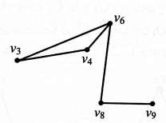

Figure 1.73(c)

**Problem 2:** Consider the graph G shown in Figure 1.74(a). Verify that the graphs G1 and

G2shown in Figures 1.74(b) and 1.74(c) are induced subgraphs of G whereas the graph G3 shown in Figure 1.74(d) is not an induced subgraph of G.

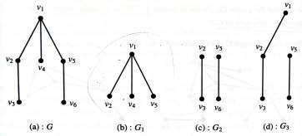

Figure 1.74

**Sol:** We note that the vertex sets of 𝐺1, 𝐺2 and 𝐺3 are all subsets of the vertex set of *G.* Further, all edges in each of 𝐺1, 𝐺2, 𝐺3 have the same end vertices in *G* as in these. Therefore, all of 𝐺1,

𝐺2, 𝐺3 are subgraphs of *G*.

Further every edge in *G* whose end vertices belong to 𝐺1 is an edge in 𝐺1.

Therefore, 𝐺1 is an induced subgraph of *G*. In fact, 𝐺1 is induced by the set {𝑣1, 𝑣2, 𝑣4, 𝑣5,}.

Similarly, 𝐺2 is an induced subgraph of *G,* induced by the set { 𝑣2,𝑣3, 𝑣5, 𝑣6,}.

The subgraph 𝐺3 of *G* is not an induced graph of *G.* Because, for example, {𝑣1, 𝑣5,} is an edge in *G* whose end vertices belong to 𝐺3, but {𝑣1, 𝑣5,} is not an edge in 𝐺3.

**Homework**

1. Let *G* be the graph shown in Figure 1.77. Verify whether 𝐺1 = (𝑉1, 𝐸1) is a subgraph of *G* in the following cases:

𝑉1 = {𝑃, 𝑄, 𝑆}, 𝐸1 = {(𝑃𝑄, 𝑃𝑆)},

𝑉1 = {𝑄}, 𝐸1 = Φ, the null set

𝑉1 = {𝑃, 𝑄, 𝑅}, 𝐸1 = {𝑃𝑄, 𝑄𝑅, 𝑄𝑆},

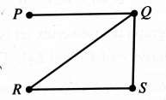

Figure 1.77

1. Three graphs 𝐺1, 𝐺2, 𝐺3 are shown in Figures 1.78(a), (b), (c) respectively. Are 𝐺2 and 𝐺3 induced subgraphs of 𝐺1? Are they spanning subgraphs?

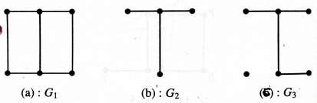

Figures 1.78

# Complement of a Simple graph

If *G is a simple graph* of order *n,* then the complement of *G* in 𝐾𝑛 is called the *complement* of

*G;*

it is denoted by

𝐺

.

(

a) G (b)

𝐺

̅

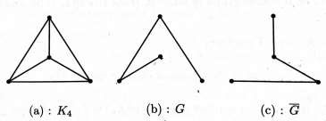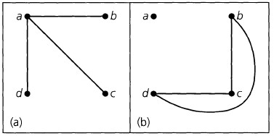

**Problem 1: a)** Let G be an undirected graph with n vertices. If G is isomorphic to its own complement 𝐺̅ (such a graph is called self –complementary), how many edges must G have? **b)** Give examples of self – complementary graphs of (i) four vertices (ii) five vertices. **Sol: a)** Let 𝑒1 be the number of edges in G and 𝑒2 be the number of edges in 𝐺̅. For any loop free undirected graph G, we have the number of edges in 𝐾𝑛 as 𝑒1 + 𝑒2 = ⬚𝑛𝐶2. Since G is

self

-

complementary,

𝑒

1

=

𝑒

2

so

𝑒

1

=

1

2

⬚

𝑛

𝐶

2

=

1

2

𝑛

(

𝑛

−

1

)

2

=

𝑛

(

𝑛

−

1

)

4

.

**b**

**)**

i)

(

Example of self

–

complementary graph with four vertices

.

(

ii)

S

elf

–

complementary graph with five vertices.

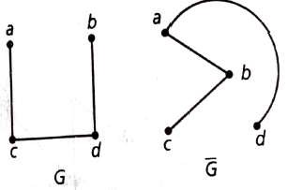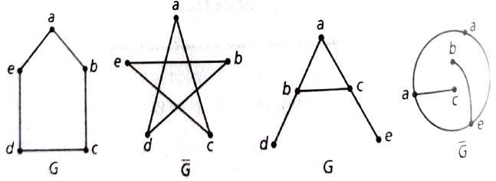

**Homework:**

1

. For the graph

*G*

and its subgraph

𝐺

1

, and

𝐺

2

shown below, find

𝐺

1

and

𝐺

2

.

2

. Find the complement of each of the following simple graphs.

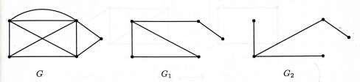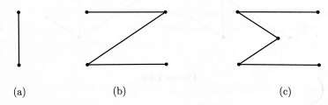

1. Draw diagrams of a self complementary graph *G* with five vertices and its complement 𝐺1.
2. Find the complement of the complete bipartite graph 𝐾3,3.

# Walk and their classifications

Let 𝑥, 𝑦 be (not necessarily distinct) vertices in an undirected graph 𝐺 = (𝑉, 𝐸). An 𝑥 − 𝑦 ***walk***in 𝐺 is a (loop free) finite alternating sequence

𝑥 = 𝑥0, 𝑒1, 𝑥1, 𝑒2, 𝑥2, 𝑒3, … , 𝑒𝑛−1, 𝑥𝑛−1, 𝑒𝑛, 𝑥𝑛 = 𝑦

of vertices and edges from 𝐺, starting at a vertex 𝑥 and ending at a vertex 𝑦 and involving the

𝑛 edges 𝑒𝑖 = {𝑥𝑖−1, 𝑥𝑖}, where 1 ≤ 𝑖 ≤ 𝑛.

The ***length*** of this walk is 𝑛, the number of edges in the walk.

When 𝑛 = 0, there are no edges, 𝑥 = 𝑦, and the walk is called ***trivial***.

Any 𝑥 − 𝑦 walk where 𝑥 = 𝑦 (and 𝑛 > 1 ) is called ***closed walk****.* Otherwise, the walk is called ***open walk****.*

Consider any 𝑥 − 𝑦 walk in an undirected graph 𝐺 = (𝑉, 𝐸).

1. If no edge in the 𝑥 − 𝑦 walk is repeated, then the walk is called an 𝑥 − 𝑦 ***trail****.* A closed 𝑥 − 𝑥 trail is called a ***circuit****.*
2. If no vertex of the 𝑥 − 𝑦 walk occurs more than once, then the walk is called an 𝑥 − 𝑦 ***path*.** When 𝑥 = 𝑦, the term ***cycle*** is used to describe such a closed path.

# Connected

Let 𝐺 = (𝑉, 𝐸) be an undirected graph. 𝐺 is *connected* if there is a path between any two distinct vertices of 𝐺. A graph that is not connected is called *disconnected.*

# Components

The fig 1.1, is an undirected graph on 𝑉 = {𝑎, 𝑏, 𝑐, 𝑑, 𝑒, 𝑓, 𝑔}. This graph is not connected because there is no path from 𝑎 to 𝑒. However, the graph is composed of pieces,

𝑉1 = {𝑎, 𝑏, 𝑐, 𝑑} and 𝑉2 = {𝑒, 𝑓, 𝑔}. These pieces are called the *components* of the graph.

For any graph 𝐺 = (𝑉, 𝐸), the number of components of 𝐺 is denoted by 𝜅(𝐺).

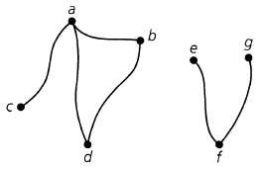

fig 1.1

# Distance

The length of the shortest path from a vertex ′𝑎′ to a vertex ′𝑏′ is the *distance* between two distinct vertices ′𝑎′ and ′𝑏′ in a connected undirected graph and is denoted by 𝑑(𝑎, 𝑏).

The following facts are to be emphasised.

1. A walk can be open or closed. In a walk (closed or open), a vertex and/or an edge can appear more than once.
2. A trail is an open walk in which a vertex can appear more than once but an edge cannot appear more than once.
3. A circuit is a closed walk in which a vertex can appear more than once but an edge cannot appear more than once.
4. A path is an open walk in which neither a vertex nor an edge can appear more than once. Every path is a trail, but a trail need not be a path.
5. A cycle is a closed walk in which neither a vertex nor an edge can appear more than once. Every cycle is a circuit; but, a circuit need not be a cycle.

***Problem:***

**1.** Determine which of the following sequences in the graph in Fig. 1.1 are walk, trail, path, circuit and cycle with its length.

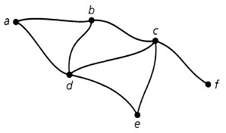

Fig. 1.1

1. {𝑎, 𝑏}, {𝑏, 𝑑}, {𝑑, 𝑐}, {𝑐, 𝑒}, {𝑒, 𝑑}, {𝑑, 𝑏}.
2. 𝑏 → 𝑐 → 𝑑 → 𝑒 → 𝑐 → 𝑓.
3. {𝑓, 𝑐}, {𝑐, 𝑒}, {𝑒, 𝑑}, {𝑑, 𝑎}.
4. {𝑏, 𝑐}, {𝑐, 𝑑}, {𝑑, 𝑏}.
5. {𝑎, 𝑏}, {𝑏, 𝑑}, {𝑑, 𝑐}, {𝑐, 𝑒}, {𝑒, 𝑑}, {𝑑, 𝑎}.
6. {𝑎, 𝑏}, {𝑏, 𝑐}, {𝑐, 𝑑}, {𝑑, 𝑎}. **Sol:**
7. {𝑎, 𝑏}, {𝑏, 𝑑}, {𝑑, 𝑐}, {𝑐, 𝑒}, {𝑒, 𝑑}, {𝑑, 𝑏}: This is an 𝑎 − 𝑏 walk of length 6.
8. 𝑏 → 𝑐 → 𝑑 → 𝑒 → 𝑐 → 𝑓: This is an 𝑏 − 𝑓 walk and a 𝑏 − 𝑓 trail of length 5.
9. {𝑓, 𝑐}, {𝑐, 𝑒}, {𝑒, 𝑑}, {𝑑, 𝑎}: This is an 𝑓 − 𝑎 walk, 𝑓 − 𝑎 trail and 𝑓 − 𝑎 path of length 4.
10. {𝑏, 𝑐}, {𝑐, 𝑑}, {𝑑, 𝑏}: This is an 𝑏 − 𝑏 closed walk of length 3.
11. {𝑎, 𝑏}, {𝑏, 𝑑}, {𝑑, 𝑐}, {𝑐, 𝑒}, {𝑒, 𝑑}, {𝑑, 𝑎}: This is an 𝑎 − 𝑎 circuit of length 6.
12. {𝑎, 𝑏}, {𝑏, 𝑐}, {𝑐, 𝑑}, {𝑑, 𝑎}: This is an 𝑎 − 𝑎 cycle of length 4.

**2.** Determine which of the following sequences in the graph in Fig. are walk, closed walk, closed trail, path and cycle.

**(a)** *b,e,f,g* (**b**) *a,b,e,f,d,a,c,d,b* (**c**) *d,f,d* (**d**) *a,b,e,f,d,c,a* (**e**) *a,c,d,f,e,b,d,a* (**f**) *a,b,d,f,e,b,d,c*

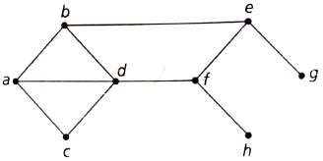

*Sol:* **(a)** none **(b**) walk, trail (**c**) walk, closed walk (**d**) walk, closed walk, trail, closed trail, cycle (**e**) walk, closed walk, trail, closed trail, (**f**) walk.

**3.** Determine **(a)** a walk from *b* to *d* that is not a trail (b) a *b-d* trail that is not a path (c) a path from *b* to *d* (d) a closed walk from *b* to *b* that is not a circuit (e) a circuit from *b* to *b* that is not a cycle and (f) a cycle from *b* to *b*.

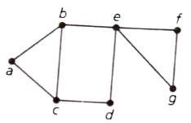

***Sol****:*

1. *{b, e}, {e, f}, {f, g}, {g, e) , {e, b}, {b, c}, {c, d}* is a walk but not a trail because the edge  *{b,e}* is repeated.
2. *{b, e}, {e, f}, {f, g}, {g, e) , {e, d},* is a trail but not a path since vertex *e*, is repeated.
3. *{b, c}, {c, d}* is a path since no vertex and no edge is repeated.
4. *{b, e}, {e, f}, {f, g}, {g, e) , {e, b}* is a closed walk (starting and ending at *b*) but is not a circuit because the edge *{b, e}* is repeated.
5. *{b, e}, {e, f}, {f, g}, {g, e) , {e, d},{d, c}, {c, b}* is a circuit but not a cycle because the vertex e is repeated.
6. *{b, e}, {e, d}, {d, c}, {c, a) , {a, b}* is a cycle where no vertex and no edge is repeated (and sequence starts and closes at *b*).

1. Find the distances from 𝑑 to (each of) the other vertices.

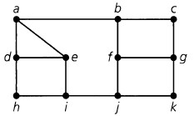

**Sol:**𝑑(𝑑, 𝑎)*:*1, 𝑑(𝑑, ℎ):1, 𝑑(𝑑, 𝑒):1, 𝑑(𝑑, 𝑖): 2, 𝑑(𝑑, 𝑏):2, 𝑑(𝑑, 𝑐):3, 𝑑(𝑑, 𝑓):3, 𝑑(𝑑, 𝑔): 4, 𝑑(𝑑, 𝑗): 3, 𝑑(𝑑, 𝑘): 4.

1. For the graph shown in figure 1.103, indicate the nature of the following walks. i) 𝑣1 𝑒1 𝑣2 𝑒2 𝑣3 𝑒2 𝑣2 ii) 𝑣4 𝑒7 𝑣1 𝑒1 𝑣2 𝑒2 𝑣3 𝑒3 𝑣4 𝑒4 𝑣5 iii) 𝑣1 𝑒1 𝑣2 𝑒2 𝑣3 𝑒3 𝑣4 𝑒4 𝑣5 iv) 𝑣1 𝑒1 𝑣2 𝑒2 𝑣3 𝑒3 𝑣4 𝑒7 𝑣1

v) 𝑣6 𝑒5 𝑣5 𝑒4 𝑣4 𝑒3 𝑣3 𝑒2 𝑣2 𝑒1 𝑣1 𝑒7 𝑣4 𝑒6 𝑣6

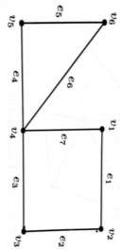 figure 1.103 **Sol:**

* 1. Open walk which is not a trail. (The edge 𝑒2 is repeated).
  2. Trail which is not a path.(The vertex 𝑣4 is repeated). iii) Trail which is a path. iv) Closed walk which is a cycle.

v) Closed walk which is a circuit but not a cycle. (The vertex 𝑣4 is repeated)

**Homework**

1. For the graph in fig 1.1, determine (a) a walk from 𝑏 to 𝑑 that is not a trail; (b) a 𝑏 − 𝑑 trail that is not a path; (c) a path from 𝑏 to 𝑑; (d) a closed walk from 𝑏 to 𝑏 that is not a circuit; (e) a circuit from 𝑏 to 𝑏 that is not a cycle; and (f) a cycle from 𝑏 to 𝑏.

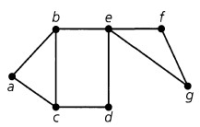 fig 1.1

1. If 𝑎, 𝑏 are distinct vertices in a connected undirected graph 𝐺, the distance from 𝑎 to 𝑏 is defined to be the length of a shortest path from 𝑎 to 𝑏. For the fig. 1.2, find the distance from 𝑑 to (each of) the other vertices in G.

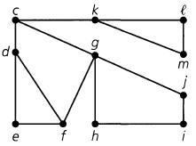

fig. 1.2

1. For the graph shown in figure 1.109, find the nature of the following walks:

(i) ABEFDACDB (ii) ABEFDCA (iii) ACDFEBDA (iv) ABDFEBDC

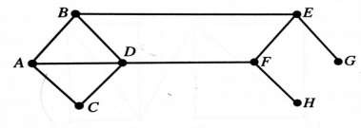 figure 1.109

# Euler circuits and Euler trails

Consider a connected graph *G*. If there is a circuit in *G* that contains all the edges of G, then that circuit is called an ***Euler circuit*** (or *Eulerian line, or Euler tour*) in *G*. If there is a *trail* in *G* that contains *all the edges* of *G*, then that trail is called an ***Euler trail*** (or *unicursal line*) in *G*. A connected graph that contains an Euler circuit is called an ***Euler graph*** (or *Eulerian graph).* A connected graph that contains an Euler trail is called a ***semi-*** ***Euler graph*** (or *semi* *Eulerian graph).*

For example, in graph shown in Figure 1.119 the closed walk

𝑃 𝑒1 𝑄 𝑒2 𝑅 𝑒3 𝑃 𝑒4 𝑆 𝑒5 𝑅 𝑒6 𝑇 𝑒7 *P* is an Euler circuit. Therefore, this graph is an Euler graph.

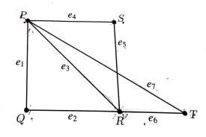

Figure 1.119

It may be seen that in the graph in Figure 1.120 the trail 𝐴𝑒1𝐵𝑒2𝐷𝑒3𝐶𝑒4𝐴𝑒5*D* is an Euler trail.

This graph is therefore a semi-Euler graph.

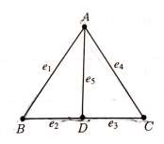

Figure 1.120

**Problem 1:** Find an Euler circuit in the graph shown below.

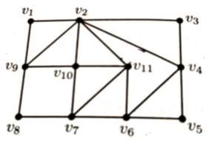

**Sol:** The Euler circuit is 𝑣1 𝑣2 𝑣9 𝑣10 𝑣2 𝑣11 𝑣7 𝑣10 𝑣11 𝑣6 𝑣4 𝑣2 𝑣3 𝑣4 𝑣5 𝑣6 𝑣7 𝑣8 𝑣9 𝑣1.

**Theorem 1.** *A connected graph G has an Euler circuit (that is, G is an Euler graph) if and only if all vertices of G are of even degree.*

Proof: First suppose that G has an Euler circuit. While tracing this circuit we observe that every time the circuit meets a vertex *v* it goes through two edges incident on *v*(- with the one through which we enter *v* and the other through which we depart from *v).* This is true for all vertices that belong to the circuit. Since the circuit contains all edges, it meets all the vertices at least once. Therefore, the degree of every vertex is a multiple of two (i.e. every vertex is of even degree)

Conversely, suppose that all the vertices of *G* are of even degree. Now we construct a circuit starting at an arbitrary vertex *v* and going through the edges of *G* such that no edge is traced more than once. Since every vertex is of even degree, we can depart from every vertex we enter, and the tracing cannot stop at any vertex other than *v.*  In this way, we obtained a circuit *q* having *v* as the initial and final vertex. If this circuit contains all the edges in *G*, then the circuit is an Euler circuit. If not, let us consider the subgraph *H* obtained by removing from *G* all edges that belong to *q*. The degrees of vertices in this subgraph are also even. Since *G* is connected, the circuit *q* and the subgraph *H* must have at least one vertex, say 𝑣′, in common. Starting from 𝑣′, we can construct a circuit 𝑞′ in *H* as was done in *G*. The two circuits *q* and𝑞′ together constitute a circuit which s and ends at the vertex *v* and has more edges than *q*. If this circuit contains all the edges in *G*, then circuit is an Euler circuit. Otherwise, we repeat the process until we get a circuit that starts from *v*  and ends at *v* and which contains all edges in *G*. In this way, we obtain an Euler circuit in *G*.

This completes the proof of the theorem.

**Homework:**

1. Show that the graph shown below is an Euler graph.

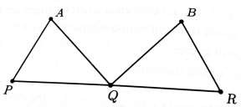

1. Show that the following graph contains an Euler trail.

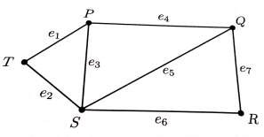

# Hamilton cycles and Hamilton paths

Let *G* be a connected graph. If there is a cycle in G that contains *all the vertices* of *G*, then that cycle is called a ***Hamilton cycle*** in *G.*

A Hamilton cycle (when it exists) in a graph of *n* vertices of consists of exactly *n* edges, because, a cycle with *n* vertices has *n* edges.

A graph that contains a Hamilton cycle is called a ***Hamilton graph*** *(or Hamilton graph)*.

For example, in the graph show in Figure 1.127, the cycle shown in thick lines is a Hamilton cycle. (Observe that this cycle does not include the edge BD). The graph is therefore a Hamilton graph.

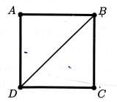

Figure 1.127

A path(if any) in a connected graph which includes every vertex (but not necessarily every edge) of the graph is called a ***Hamilton path*** ***(or Hamilton graph)*** in the graph.

For example, in the graph shown in Figure 1.128, the path shown in thick lines is a Hamilton path.

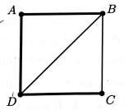

Figure 1.128

In the graph shown in Figure 1.129, the path *ABCFEDGHI* is a Hamilton path.

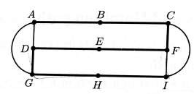

Figure 1.129

**Problem 1:** Show that the Petersen graph has a Hamilton path.

* The Petersen graph is a 3-regular graph with 10 vertices and 15 edges. The graph is shown below with the vertices labeled as A, B, C, D, E, L, M, N, P, Q.

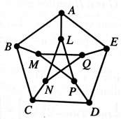

We note that the edges AB, BC, CD, DE, EQ, QM, MP, PL, LN form a path and this path includes all vertices. This path is therefore a Hamilton Path. Thus, the Petersen graph does have a Hamilton path in it.

**Problem 2:** Show that the graph shown in Figure 1.132 is a Hamilton graph.

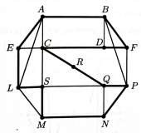

Figure 1.132

* By examining the given graph, we notice that in the graph there is a cycle AELSMNPQRCDFBA which contains all the vertices of the graph. This cycle is a Hamilton cycle. Since the graph has a Hamilton cycle in it, the graph is a Hamilton graph

**Problem 3:** Exhibit the following:

* 1. A graph which has both an Euler circuit and a Hamilton cycle.
  2. A graph which has an Euler circuit but no Hamilton cycle.
  3. A graph which has a Hamilton cycle but no Euler circuit.
  4. A graph which has neither a Hamilton cycle nor an Euler circuit.

* The graphs (a) –(d) shown below are the required graphs in the desired order.

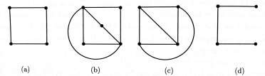

**Homework:**

1. Show that the following graphs are Hamiltonian graphs:

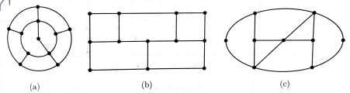

1. Which of the following are Euler graphs? Hamilton graphs?

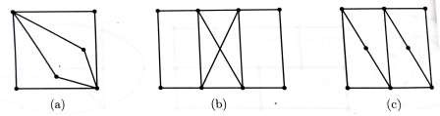

**The Traveling Salesman Problem**

A problem closely related to the question of Hamiltonian circuits is the traveling-salesman problem, stated as follows: A salesman is required to visit a number of cities during a trip. Given the distances between the cities, in what order should he travel so as to visit every city precisely once and return home, with the minimum mileage travelled?

Representing the cities by vertices and the roads between them by edges, we get a graph. In this graph, with every edge 𝑒𝑖 there is associated a real number (the distance in miles, say), 𝑤(𝑒𝑖). Such a graph is called a weighted graph; 𝑤(𝑒𝑖) being the weight of edge 𝑒𝑖.

In our problem, if each of the cities has a road to every other city, we have a complete weighted graph. This graph has numerous Hamiltonian circuits, and we are to pick the one that has the smallest sum of distances (or weights).

The total number of different (not edge disjoint, of course) Hamiltonian circuits in a complete graph of n vertices can be shown to be (n − l)!/2. This follows from the fact that starting from any vertex we have n − 1 edges to choose from the first vertex, n − 2 from the second, n − 3 from the third, and so on. These being independent choices, we get (n − 1)! possible number of choices. This number is, however, divided by 2, because each Hamiltonian circuit has been counted twice.

Theoretically, the problem of the traveling salesman can always be solved by enumerating all

(n − l)!/2 Hamiltonian circuits, calculating the distance travelled in each, and then picking the shortest one. However, for a large value of n, the labor involved is too great even for a digital computer (try solving it for the 50 state capitals in the United States; n = 50).

The problem is to prescribe a manageable algorithm for finding the shortest route. No efficient algorithm for problems of arbitrary size has yet been found, although many attempts have been made. This problem has applications in operations research. There are also available several heuristic methods of solution that give a route very close to the shortest one, but do not guarantee the shortest.

*****